Marcelo Schonbrunn Bonnin

A01207573

Investigación 2 BD

**ORACLE**

**- Requerimientos Generales de Hardware**

Los servidores deben de contar con un procesador, con memoria RAM y espacio de disco duro. Los requisitos mínimos de los servidores dependen del tamaño, la siguiente tabla de IBM depicta los requisitos.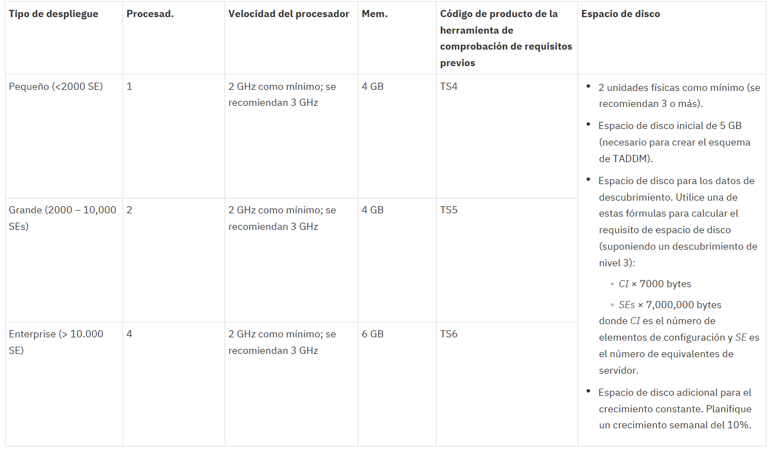

Según la página de oracle, los requisitos para un servidor Oracle son:

Additionally, for a complete installation of Oracle Communications Data Model, the minimum hardware requirement is disk space of at least 10 GB.

The minimum hardware requirement for Oracle Communications Data Model Sample Reports installation is disk space of at least 25 GB.

**- Ambientes o plataformas en las que pueden operar.**

Según la página de oracle, las versiones soportadas son las siguientes:

* Linux *x*86-64
  + Asianux Server 3 SP2 and higher
  + Oracle Linux 5 Update 2 and higher
  + Oracle Linux 5 Update 5 (with the Oracle Unbreakable Enterprise Kernel for Linux)
  + Red Hat Enterprise Linux 5 Update 2
  + Red Hat Enterprise Linux 5 Update 5 (with the Oracle Unbreakable Enterprise Kernel for Linux)
  + Red Hat Enterprise Linux 6
  + SUSE Linux Enterprise Server 10 SP2
  + SUSE Linux Enterprise Server 11
* Oracle Solaris on SPARC (64-bit)
  + Oracle Solaris 10 U6 (5.10-2008.10)
  + Oracle Solaris 11 11/11 SPARC
* Oracle Solaris on x86-64 (64-bit)
  + Oracle Solaris 10 U6 (5.10-2008.10)
  + Oracle Solaris 11 11/11 X86
* IBM AIX on POWER Systems (64-bit)
  + AIX 6.1 TL 02 SP1 ("6100-02-01"), 64-bit kernel
  + AIX 7.1 TL 0 SP1 ("7100-00-01-1037"), 64-bit kernel

https://docs.oracle.com/cd/E11882_01/doc.112/e28441/require.htm#CDMIG109

**- Costos de implementación y mantenimiento**

**2009 license cost of Oracle 11g Standard Edition**

- Per Processor = $17,500

- Support (22%) = $3,850

- Total (Per Processor) = $21,350

- Total (4 Processors) = $85,400

**2009 license cost of Oracle 11g Standard Edition One**

- Per Processor = $5,800

- Support (22%) = $1,276

- Total (Per Processor) = $7,076

- Total (2 Processors) = $14,152

**2009 license cost of SQL Server 2005 Standard Edition**

- Per Processor = $5,999

- Total (4 Processors) = $23,996

**2009 license cost Cost Ratio:**

- Oracle SE to MSSQL SE = 2.56

- Oracle SEO to MSSQL SE = -0.41

**- Ventajas y desventajas de su uso.**

Ventajas:

* Mas poderoso
* Flexible

Desventajas:

* Caro

http://www.dba-oracle.com/t_cost_sql_server_vs_oracle.htm

**- Porcentaje del mercado que controlan**

Oracle, meanwhile, dropped 1.5 points to 41.6 percent while IBM shed 5.6 points to settle in at 16.5 percent.

<https://www.infoworld.com/article/3056637/database/nosql-chips-away-at-oracle-ibm-and-microsoft-dominance.html>

**SQL SERVER**

**- Requerimientos Generales de Hardware**

|  |  |
| --- | --- |
| Component | Requirement |
| .NET Framework | SQL Server 2016 RC1 and later require .NET Framework 4.6 for the Database Engine, Master Data Services, or Replication. SQL Server 2016 setup automatically installs .NET Framework. You can also manually install .NET Framework from [Microsoft .NET Framework 4.6 (Web Installer) for Windows](http://support.microsoft.com/kb/3045560).  For more information, recommendations, and guidance about .NET Framework 4.6 see [.NET Framework Deployment Guide for Developers](http://msdn.microsoft.com/library/ee942965(v=vs.110).aspx).  Windows 8.1, and Windows Server 2012 R2 require [KB2919355](http://support.microsoft.com/kb/2919355) before installing .NET Framework 4.6. |
| Netwok Softwarre | Supported operating systems for SQL Server have built-in network software. Named and default instances of a stand-alone installation support the following network protocols: Shared memory, Named Pipes, TCP/IP and VIA.  Note: Shared memory and VIA are not supported on failover clusters.  Also note that the VIA protocol is deprecated. This feature will be removed in a future version of Microsoft SQL Server. Avoid using this feature in new development work, and plan to modify applications that currently use this feature.  For more information about Network Protocols and Network Libraries, see [Network Protocols and Network Libraries](https://docs.microsoft.com/en-us/sql/sql-server/install/network-protocols-and-network-libraries). |
| Hard Disk | SQL Server requires a minimum of 6 GB of available hard-disk space.  Disk space requirements will vary with the SQL Server components you install. For more information, see [Hard Disk Space Requirements](https://docs.microsoft.com/en-us/sql/sql-server/install/hardware-and-software-requirements-for-installing-sql-server#HardDiskSpace) later in this article. For information on supported storage types for data files, see [Storage Types for Data Files](https://docs.microsoft.com/en-us/sql/sql-server/install/hardware-and-software-requirements-for-installing-sql-server#StorageTypes). |
| Drive | A DVD drive, as appropriate, is required for installation from disc. |
| Monitor | SQL Server requires Super-VGA (800x600) or higher resolution monitor. |
| Internet | Internet functionality requires Internet access (fees may apply). |

|  |  |
| --- | --- |
| Component | Requirement |
| Memory * | **Minimum:**  Express Editions: 512 MB  All other editions: 1 GB  **Recommended:**  Express Editions: 1 GB  All other editions: At least 4 GB and should be increased as database size increases to ensure optimal performance. |
| Processor Speed | **Minimum:** x64 Processor: 1.4 GHz  **Recommended:** 2.0 GHz or faster |
| Processor Type | x64 Processor: AMD Opteron, AMD Athlon 64, Intel Xeon with Intel EM64T support, Intel Pentium IV with EM64T support |

<https://docs.microsoft.com/en-us/sql/sql-server/install/hardware-and-software-requirements-for-installing-sql-server>

**- Ambientes o plataformas en las que pueden operar.**

The SQL Server editions are classified into the following:

* [Principal Editions](https://docs.microsoft.com/en-us/sql/sql-server/install/hardware-and-software-requirements-for-installing-sql-server#TOP_Principal)
* [Breadth Editions](https://docs.microsoft.com/en-us/sql/sql-server/install/hardware-and-software-requirements-for-installing-sql-server#TOP_Breadth)

Windows Server 2016 Datacenter

Windows Server 2016 Standard

Windows Server 2016 Essentials*

Windows Server 2012 R2 Datacenter

Windows Server 2012 R2 Standard

Windows Server 2012 R2 Essentials

Windows Server 2012 R2 Foundation

Windows Server 2012 Datacenter

Windows Server 2012 Standard

Windows Server 2012 Essentials

Windows Server 2012 Foundation

SQL Server Standard

Windows Server 2016 Datacenter

Windows Server 2016 Standard

Windows Server 2016 Essentials*

Windows Server 2012 R2 Datacenter

Windows Server 2012 R2 Standard

Windows Server 2012 R2 Essentials

Windows Server 2012 R2 Foundation

Windows Server 2012 Datacenter

Windows Server 2012 Standard

Windows Server 2012 Essentials

Windows Server 2012 Foundation

Windows 10 Home

Windows 10 Professional

Windows 10 Enterprise

Windows 10 IoT Enterprise

Windows 8.1

Windows 8.1 Pro

Windows 8.1 Enterprise

Windows 8

Windows 8 Pro

Windows 8 Enterprise

SQL Server Web

Windows Server 2016 Datacenter

Windows Server 2016 Standard

Windows Server 2016 Essentials*

Windows Server 2012 R2 Datacenter

Windows Server 2012 R2 Standard

Windows Server 2012 R2 Essentials

Windows Server 2012 R2 Foundation

Windows Server 2012 Datacenter

Windows Server 2012 Standard

Windows Server 2012 Essentials

Win

dows Server 2012 Foundation

**- Costos de implementación y mantenimiento.**

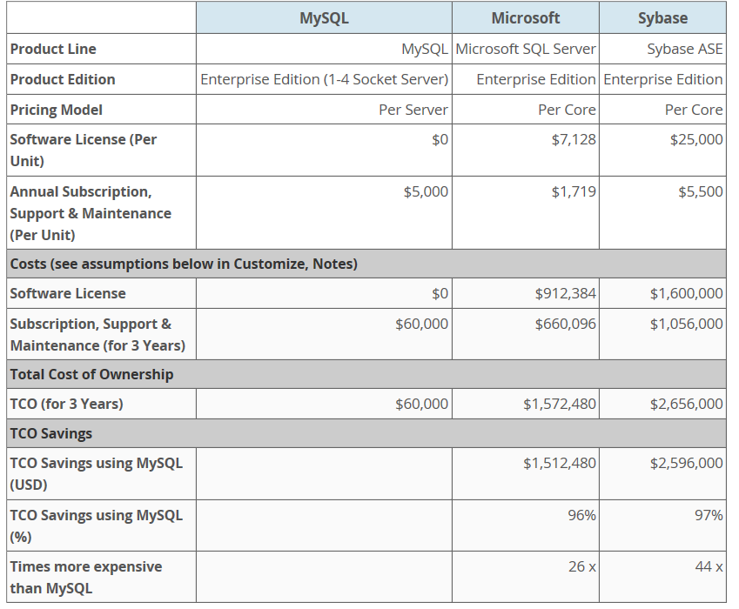

[**https://www.mysql.com/tcosavings/**](https://www.mysql.com/tcosavings/)

**- Ventajas y desventajas de su uso.**

Ventajas:

* Mucho software de manejo de bdms
* Recuperacion de informacion

Desventajas

* Las licencias son caras

**- Porcentaje del mercado que controlan**

19.4

**MYSQL**

**- Requerimientos Generales de Hardware**

#### **Recommended Hardware Requirements**

This section describes the recommended hardware requirements for the Enterprise Service Manager.

* 4 CPU Cores or more
* 8 GB RAM or more
* RAID10 or RAID 0+1 disk setup

[**https://dev.mysql.com/doc/mysql-monitor/4.0/en/system-prereqs-reference.html**](https://dev.mysql.com/doc/mysql-monitor/4.0/en/system-prereqs-reference.html)

**- Ambientes o plataformas en las que pueden operar.**

Oracle, Apple, FreeBSD, Linux

**- Costos de implementación y mantenimiento.**

5000 USD

**- Ventajas y desventajas de su uso.**

Ventajas

* Facil de usar
* Open source
* Muy barato

Desventajas

* No es 100% estable
* Viene con pocas funciones
* Tiene muchas limitaciones

<https://dev.mysql.com/doc/mysql-monitor/4.0/en/system-prereqs-reference.html>

**- Porcentaje del mercado que controlan**

44.3%

**DBMS NO RELACIONAL (MARIA DB)**

**- Requerimientos Generales de Hardware**

MariaDB doesn't have minimal hardware requirements per se, or if there was any, it would correspond to pre-2000 machines which don't exist anymore. So it mostly depends on what you intend to do with it. Tarball is approximately 400MB, by my last count. Packages are much less than that.

<https://mariadb.com/kb/en/library/mariadb-hardware-requirements/>

**- Ambientes o plataformas en las que pueden operar.**

The critical software in any database management system is its storage engine, which manages queries and interfaces between a user's SQL statements and the database's back-end storage. MariaDB offers several storage engines with different advantages. Some are transaction-safe storage engines that allow for rollback of data.

MariaDB also offers full integration with Galera cluster — an add-on for MariaDB for running multiple database servers for better performance and high availability. This is just one of many examples of how MariaDB integrates well with other software and systems. Such integration and MariaDB new encryption features have made it the premier database.

<https://mariadb.com/kb/en/library/about-mariadb-software/>

**- Costos de implementación y mantenimiento.**

0

**- Ventajas y desventajas de su uso.**

#### **Pros of MariaDB vs MySQL**

1. MariaDB has better query performance.
2. MariaDB has more of an open source attitude.
3. Switching to MariaDB is easy.
4. Galera implementation is better in MariaDB.
5. MariaDB is available as an option with some hosting environments, like RackSpace Cloud.
6. MariaDB comes by default with some distros, like the Red Hat series.

#### **Cons of MariaDB vs MySQL**

* Switching back from MariaDB to MySQL may not be so easy.
* If you are using AWS, Amazon Aurora may be even faster than MariaDB and MySQL.
* Your Operating System may not support MariaDB yet.
* Your hosting environment may not support MariaDB yet.
* Percona may be an even better option than MariaDB.

**- Porcentaje del mercado que controlan**

No encontre informacion :(

**CONCLUSION:**

Existen muchas opciones para manejar un servidor. Oracle parece ser la mejor opción pero resulta ser muy caro para nuestro proyecto. SQL server es una buena segunda opción pero igualmente es demasiado caro para el tipo de proyecto que estamos haciendo. Quedan dos posibilidades. Podemos usar Mysql o MariaDB. Según todas las fuentes, Mysql no es muy buena opción. Es básicamente gratis pero no viene con mucha funcionalidad y no es estable. Por otra parte, mariaDb también es grátis y viene con mucha más funcionalidad que Mysql, por esto creo que usar MariaDb podría ser buena opción para nuestro proyecto.